A Quick Guide to Teamwork Spaces

This quick start guide provides a brief overview on how to log into Teamwork Spaces and what will be available to you during the InterOpathon. Please note some images in this guide are from a previous event and your Team’s Space may look slightly different.

1. **Create an Account**
   1. An invitation email from support@teamwork.com will be sent to every event participant

* 1. Click the link provided in the email to be redirected to the account setup page

* 1. Sign up by providing a first name, last name, and password of choice. After agreeing with Teamwork’s Privacy Statement, click “Finish sign up” to be redirected to the last page of setup.

* 1. Click “Get started” to enter the event space

1. 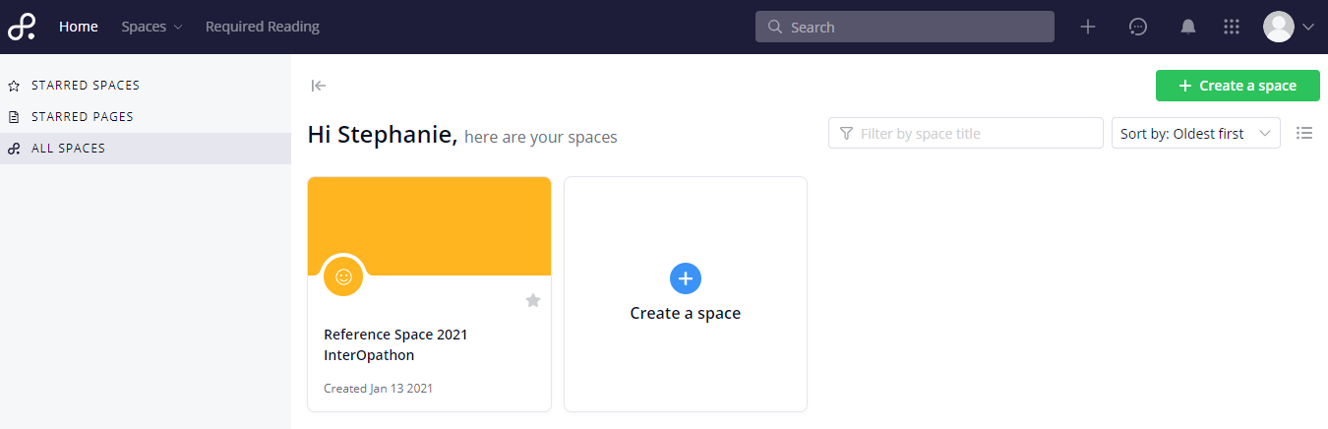**Log in** 
   1. After account creation you will automatically be redirected to the Teamwork Spaces home page. On this page there will be a space with your team number (see example to the right). Click anywhere on your team’s square to enter your team’s event space.

***\*\*\*You will only be able to see the space of the team admin added you to. If you were added to the wrong team, please reach out to our help desk via Slack.***

1. **Explore Team Space -** 
   1. Below is an example of what you should see after entering your team’s space (minus a few admin buttons). Click around to become familiar with this platform.

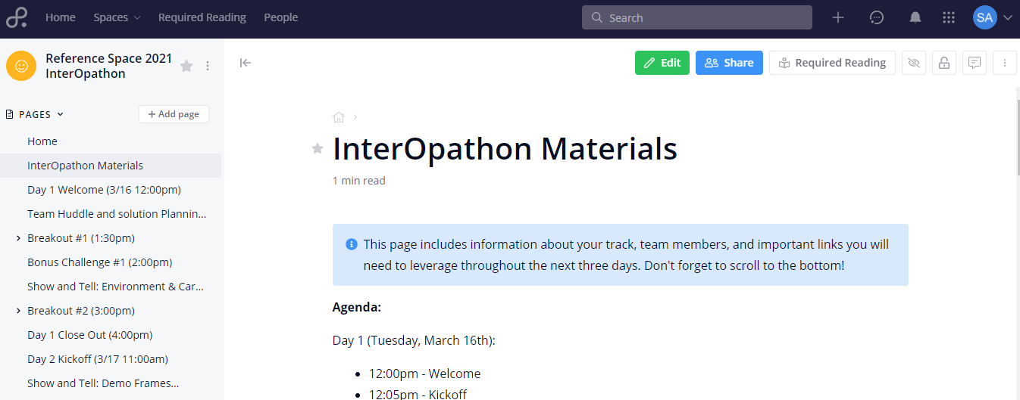

On the **left** of the screen there will be a **navigation menu** that doubles as an **agenda.** Activities for all three days of the InterOpathon can be found within these tabs. To complete the material during the event, start at the top and work your way down.

Note the agenda/nav items that have an arrow next to them. These items contain nested pages. Which page you will complete depends on the role you have within your team.

The center/main part of the webpage contains information on the activities for the **selected agenda item**. Scroll to the bottom of the page to receive all of the directions and locate any worksheets that need to be completed.

*An example of instructions and worksheet found at the bottom of a page.*

1. **Teamwork Chat**

This Teamwork feature will be utilized during the InterOpathon for private team messaging and public event communication.

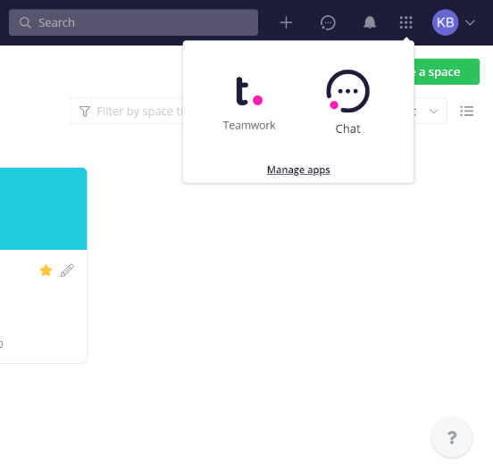

* 1. Navigate to Teamwork Chat using the icon in the top right portion of the screen. You will also be able to navigate back to Teamwork Spaces using this same feature.
  2. 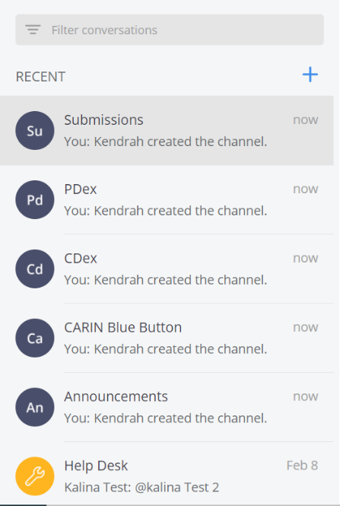Once in Teamwork Chat, you will be able to access your Team’s private channel, a help desk channel, the announcement channel, the Use Case Channels, and the submissions channel.
  3. The **team’s private** **channel** will be used to communicate, share documents, and ensure you are on the right track with your solutions. Your team will be assigned a number prior to the event starting.
  4. The **Help Desk, Announcement, and Use Case Channels** will be used for communication to all participants. It will also allow participants to communicate with Use Case SMEs and IOL Help Desk associates. The submissions channel is where your final recordings will be posted.
  5. Type a message in the box and use the gray arrow on the right to send it. To attach documents, your final presentation, or your final recordings use the blue paperclip on the left

